Implementation of Haptic Output for an Ultrasonic Guidance System for the Visually Impaired
Jamil Mangrio
Automation and Robotics Senior Research Lab

Table of Contents
Abstract……………………………………………………………………………………………3
Introduction………………………………………………………………………………………..4
Methodology………………………………………………………………………………………5
Results …………………………………………………………………………………………….6
Discussion…………………………………………………………………………………………7
Conclusion………………………………………………………………………………………...8
Final Comments…………………………………………………………………………………...9
Works Cited……………………………………………………………………………………...10
Appendix………………………………………………………………………………………....11

Abstract
The primary objective of this project is to develop and implement a wearable device to effectively provide guidance for the visually impaired. Therefore, the device should be able to detect its surroundings and relay that information to the wearer in a way that does not involve sight. This resulted in the design of a haptic output system mated to an array of ultrasonic sensors on a helmet-mounted device. While the final goal of a functioning device was not realized, the design provides an ergonomic and feasible implementation of a haptic system and a good basis for future applications.

Introduction
Wearable technology is becoming increasingly prevalent in today’s world, manifested in products such as smartwatches, virtual reality headsets, and smart glasses. Its popularity is largely due to its convenience, a quality which is essential to the field of assistive technology. Currently, wearable technology is used mostly for entertainment with some productivity aspects. It is being developed and marketed in conjunction with the theory of the “internet of everything”, an idea in which all of a person’s technology can be connected and share one “mind”. In effect, smartwatches serve as extensions of smartphones by displaying notifications and allowing responses to messages, providing another layer of accessibility to already successful and popular products. Despite their growing popularity and potentially incredible applications, however, wearables have not extended to the field of assistive technology, where accessibility may be valued the most.
The aim of this project is to implement wearable technology in a product designed to aid the visually impaired. Its significance is in providing a proof of concept of the effectiveness of wearables in aiding disabled people. It should be noted, however, that effective and marketable wearables usually implement the best of small and easily packageable components, and that due to budget and expertise limitations, a similar level of quality was not expected from this project. The purpose was to prove the potential effectiveness of wearables in the field of assistive technology.

Methodology
The design itself consists of a helmet with ultrasonic sensors around the side of it oriented in the horizontal plane. Each sensor corresponds to a haptic motor placed in relatively the same location as the sensor on the wearer’s head. The sensors and motors are connected through the Arduino, and the motors are driven by a vibration motor control unit. As a sensor detects an object or surface, it relays that information to the microcontroller, which is programmed to signal the motor control unit to drive the motors at varying intensities or pulse patterns, depending on the distance and relative velocity of the detected object.
The purpose of this wearable is to be as user-friendly and accessible as possible. This principle was kept in mind when the helmet design was chosen; a helmet with sensors and vibration motors is about as simple as a wearable white cane replacement is going to get. A helmet is practical and easy to take on and off when necessary, provided the entirety of the device and its power supply are contained on it. Additionally, the helmet allows for the wearer to sense obstructions with respect to their head, in the same way as a healthy person naturally would. A helmet can also provide a full 360-degree view around the wearer, another big positive for the design.
The project did not get to the stage of full and final testing, but the ultrasonic sensors were able to sense the distance of objects, showing that that aspect of the device would have worked.

Results
The result of the project was not as hoped. The project did not reach completion, so the full device was not ready for testing. However, the ultrasonic sensors were tested and were effective, so they and the circuit used would be a good option for a completed version of this device. Below is an image of the circuitry for the ultrasonic sensors, the components which were effective.

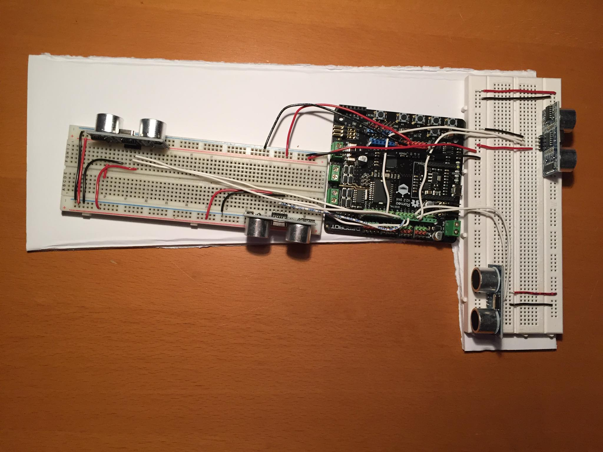

Discussion
Despite the fact that a working prototype was not finished, the concept behind this project is sound with expansive future implications. As a prototype assistive wearable device, the project proves that wearables can be very effective in aiding those with disabilities.
The base platform of this project can be greatly expanded in the future. Further refinement is very much necessary, and can lead to a very effective final product. The current structure of the device is very clunky and spread out, and does not have nearly enough sensors as would be ideal. Smaller sensors, more efficient spacing and wiring, and a larger number of sensors and motors will all greatly improve upon the device, and can even make it usable for a relatively low cost. Additionally, the haptic output component can be made to be very advanced and intuitive, providing varying frequencies and intensities for varying scenarios. Additional layers of complexity can be added; things such as alerts for velocities or beginnings of relaying sizes of objects to the wearer. Another possibility is replacing the ultrasonic sensors with a rotating laser distance sensor to provide a full “image” efficiently for the wearer to interpret. That would require a more advanced output system than haptic motors could provide, but would utilize the same concept of the wearable to achieve the goal of providing 360-degree awareness to those who cannot see.

Conclusion
In conclusion, despite this project’s shortcomings, it provides a good basis for future expansion of such an assistive wearable device. The design is greatly expandable with the examples listed above, and the assistive wearable field is largely unexplored. There is much room to grow and improve upon the ideas utilized in this project, and they can be used to great effect in the future.

Final Comments
I would like to thank my lab director, Mr. Dela Cuesta, for his guidance and patience throughout this project. I would also like to thank my school for funding the project and for the stellar education it has provided me over the last four years.

Works Cited
National Center for Statistics and Analysis. (2017, February). Pedestrians: 2015 data. (Traffic Safety Facts. Report No. DOT HS 812 375). Washington, DC: National Highway Traffic Safety Administration.
Schwebel, D. C., Stavrinos, D., Byington, K. W., Davis, T., O’Neal, E. E., Jong, D. d. (2012). Distraction and pedestrian safety: How talking on the phone, texting, and listening to music impact crossing the street. Science Direct. Retrieved from http://www.sciencedirect.com/science/article/pii/S0001457511001965
Ultrasonic Sensor - HC - SR04. Retrieved from https://www.sparkfun.com/products/13959
Castle, A (2013). Know your Arduino: A Practical Guide to the Most Common Boards. Retrieved from http://www.tested.com/tech/robots/456466-know-your-arduino-guide-most-common-boards/

Appendix
